|  |  |  |
| --- | --- | --- |
| **LAB 321Assignment** | **Type:** | **LongAssignment** |
| **Code:** | **J3.L.P0017** |
| **LOC:** | **800** |
| **Slot(s):** | **15** |

**Title:** Aromatherapy – Massage Services

**Background**

### Your girlfriend want to start up with her Aromatherapy– Massage Services

Your mission is help her to develop a website to promote her service to everyone

Reference site:<http://www.simplesite.com/us-123health>

**Program Specifications**

Program a web site tointroduce Aromatherapy– Massage Services, detail functions of this website is described below

**Features:**

This website contains 5 main functions

* Function 1 : Home page : ( see PIC 01)
  + Display introduction entry
  + Display top 3 latest introduction post
  + Display all course sort by date
  + Display contact infor
* Function 2 : Aromatherapy– Massage( PIC 02)
  + Display all post about your services
* Function 3:price( PIC 03)
  + Display detail prices of all your services
* Function 4 Employee
  + Display your experts information
* Function 5: Contact
  + Display contact information in detail

You do not need to write interface for admin control panel, you can add data manually (use SQL SERVER Management studio).

Note: All data must be load from database, not hard code in page.

***Expectation of User interface:***

Pic 01 : Home Page

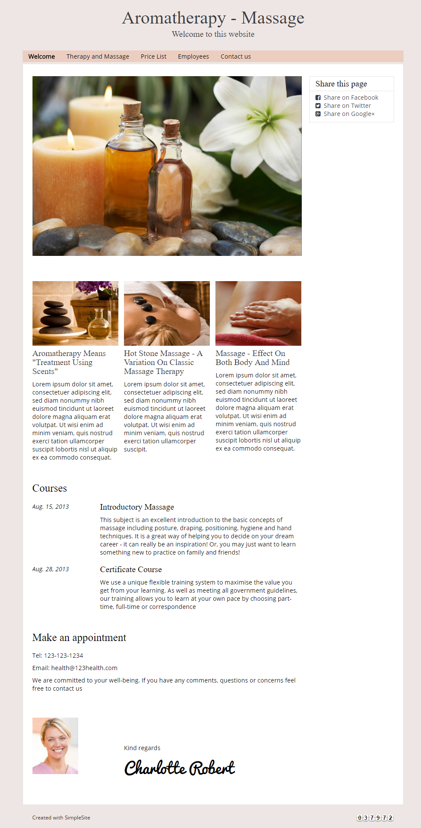

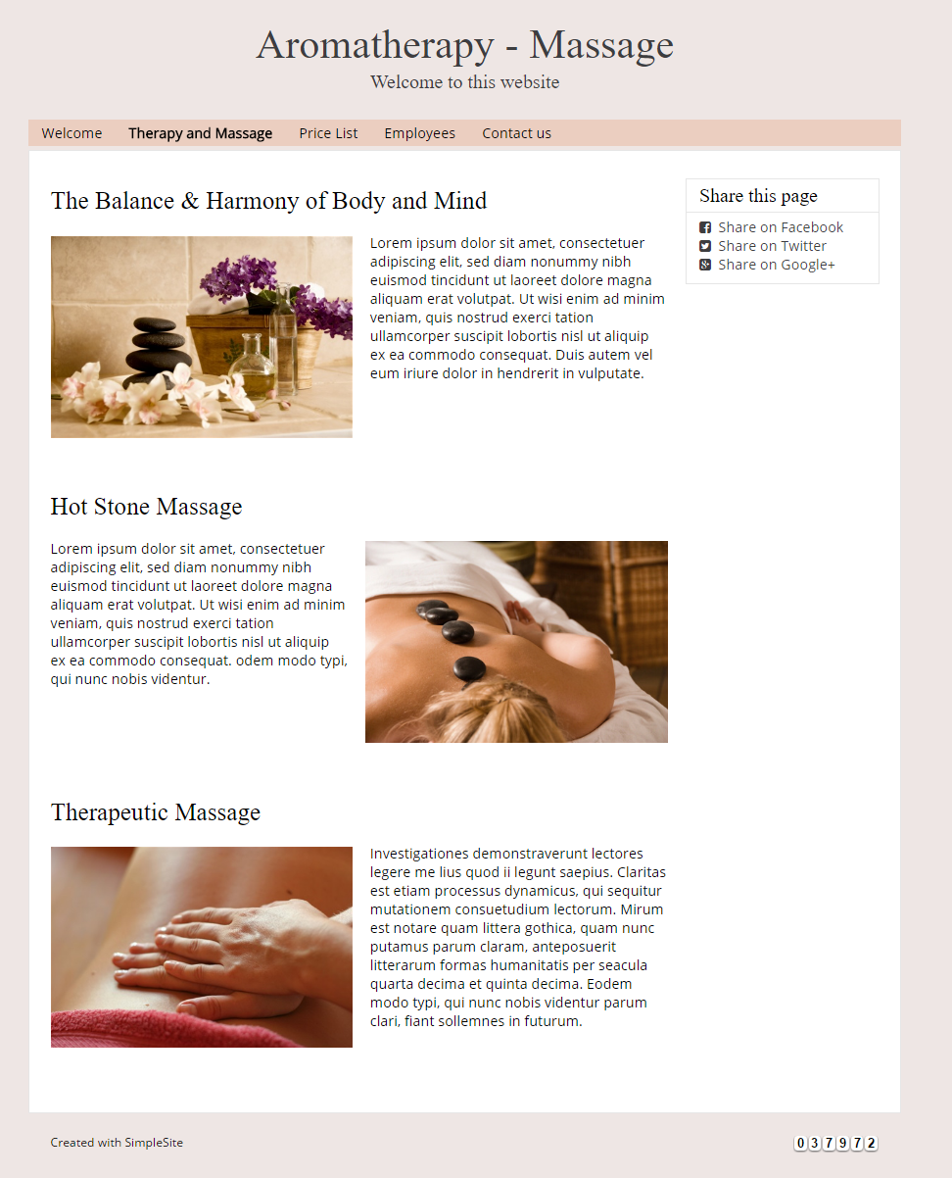

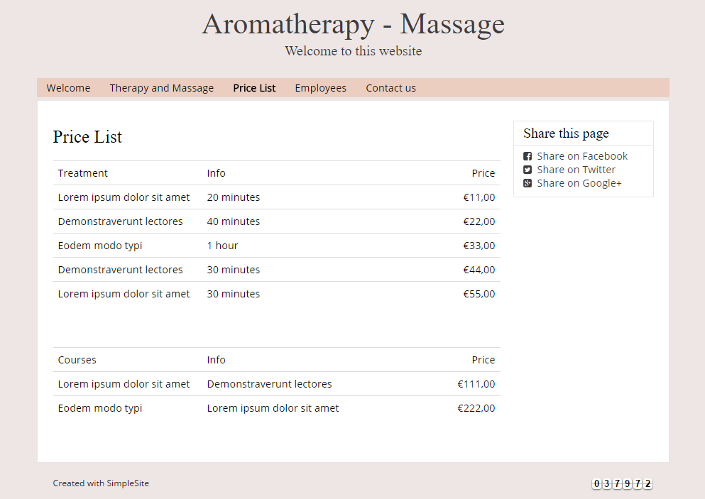

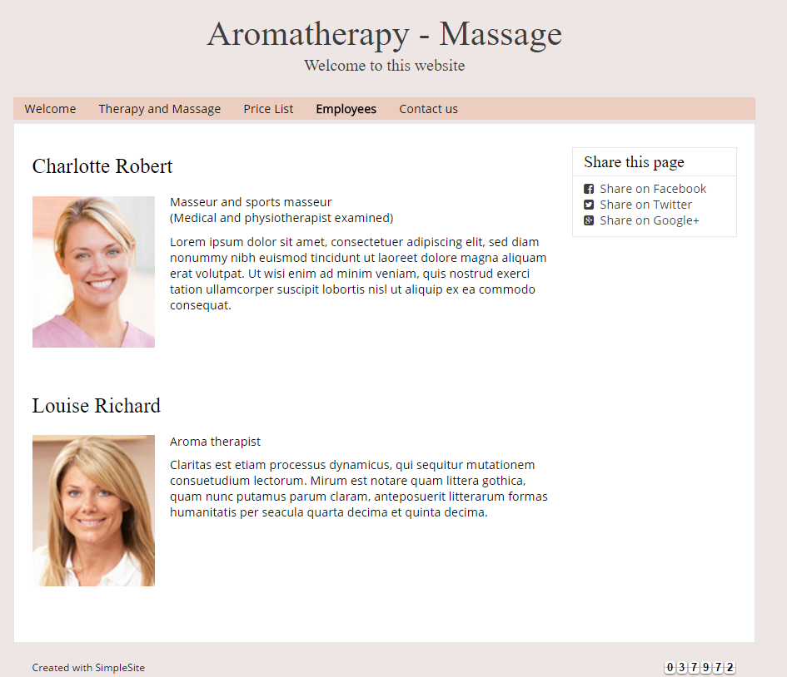

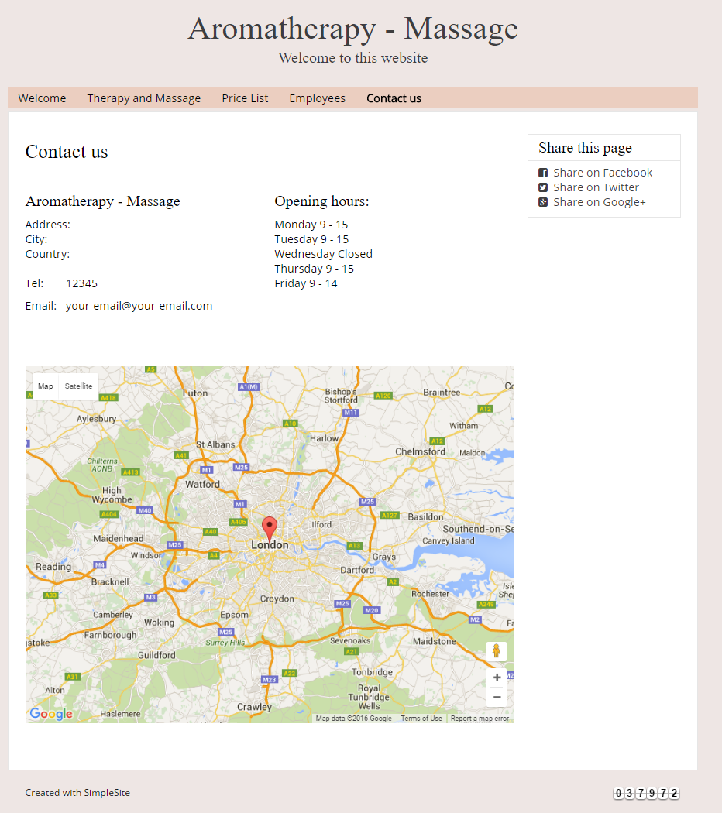

**Guidelines**

* Step 1 : Clarify requirement , check with mentor until you clear all the requirement
* Step 2 : Create web layout and create prototype
* Step 3 : Design database base on created prototype
* Step 4 : Code & Test